CDK required API’s
Service
CDK Drive Async Closed Repair Order ($0.29 per call)
- https://apidocs.fortellis.io/async-apis/9c312e51-006f-487e-83bf-f71b29ffb3fd

Components

- Customer
  - customerId
  - Name1:
  - phoneNumbers
  - emailAddressess
- repairOrderPayload
  - roNumber: "284399"
  - customerId: "111111"
  - phoneNumbers:
    - Number: "1111111"
    - description: Cellular
- emailAddresses:
  - Desc: Home
Address: abc@company.com
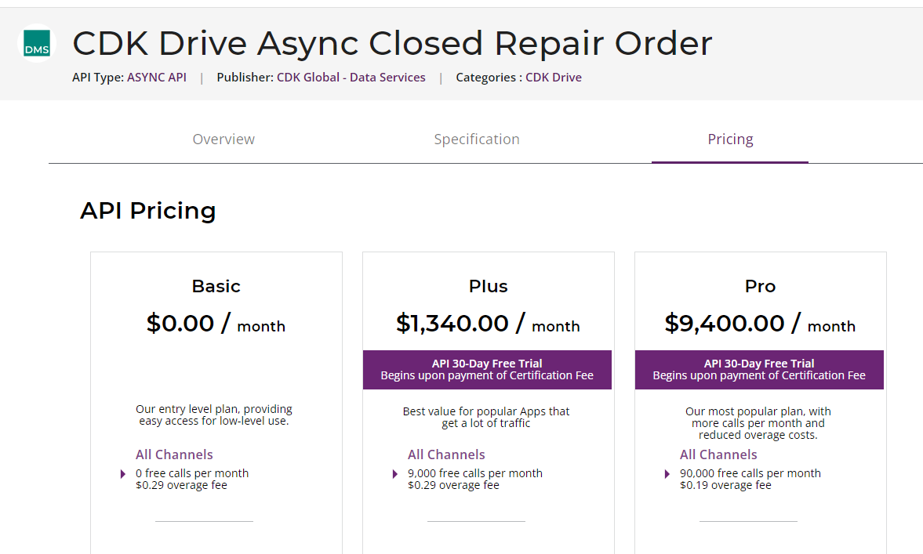
Sales
CDK Get FI Sales ($6 per call)
-https://apidocs.fortellis.io/apis/b54ba111-7874-4c25-b8d9-ba3b3eb722ef
- Components
  - "data": [
{
"buyer": {
"customerId": "34567",
"fullName": "Doe, Jane M",
},
"homePhone": "5554443333",
"emailAddresses": {
"address": "john.doe@example.com",
"type": "Home"
},
},
"crm": {
"crmSalesperson1": {
"employeeId": 998161,
"employeeName": "SALESPERSON,JANE ELLEN",
"commission": 1,
"saleCredit": 500,
"spiff": null
},
"crmSalesperson2": {
"employeeId": 998165,
"employeeName": "SALESPERSON,TORRY C",
"commission": 1,
"saleCredit": 500,
"spiff": null
},
"crmSalesperson3": {
"employeeId": null,
"employeeName": null,
"commission": null,
"saleCredit": 0,
"spiff": null
}
},
"deal": {
"dealNo": "4669120",
}
},
